Newborn screening for scid

“State of the Art”
2020 will mark 10 years since the inclusion of SCID within the Recommended Uniform Screening Panel in the USA.
During that time much has been learned and a number of countries outside the US have begun to evaluate, operate or plan newborn screening programmes.
The International Society for Neonatal Screening and the UK Newborn Screening Laboratories Network are pleased to host a meeting of leaders in the field from around the world to discuss progress.

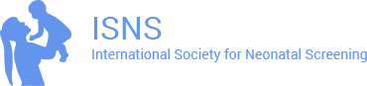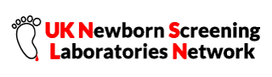
18th MAY 2020
The meeting will begin at 09.30 and close at 16.30
It is to be held at Heathrow Airport at the Park Inn by Radisson Hotel & Conference Centre, London, Heathrow, Bath Road, Middlesex, UB7 0DU
The registration fee for the one day meeting is : £40 payable to ISNS
Register at: https://membership.isns-neoscreening.org/member/conferences/

